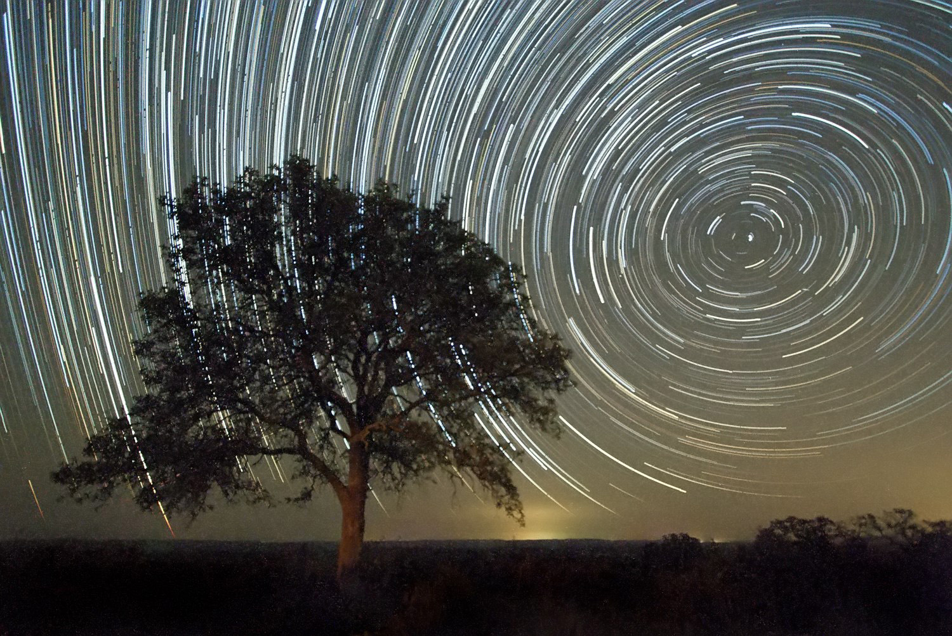

(Credit: Ralph Arvesen, Live Oak star trails, <https://www.flickr.com/photos/rarvesen/9494908143>, <https://creativecommons.org/licenses/by/2.0/legalcode>)

**Where is the North Star?**

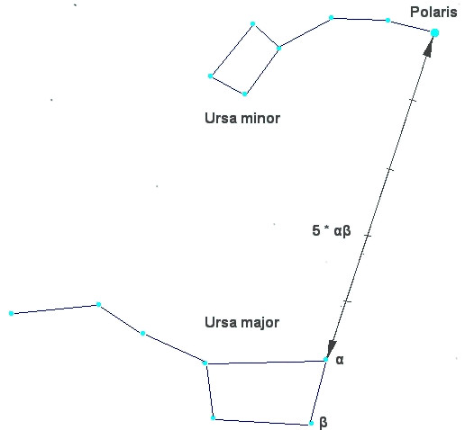

(Credit: Bonč, <https://commons.wikimedia.org/wiki/File:Ursa_Major_-_Ursa_Minor_-_Polaris.jpg>, “Ursa Major – Ursa Minor – Polaris”, based on <https://commons.wikimedia.org/wiki/File:Ursa_Major_and_Ursa_Minor_Constellations.jpg>, cropped and colours inverted by Markus Nielbock, <https://creativecommons.org/licenses/by-sa/3.0/legalcode>)

**Building instructions of the Kamal**

Material needed:

* one piece of ply wood (preferred) or very stiff card board (21 cm x 12 cm x 4 mm)
* 50 cm of cord
* Pencil
* Ruler
* Saw (for the wood) or scissors (for the cardboard), if the board has to be cut to fit the size needed
* Drill (for the wood) or thick needle (for the cardboard)

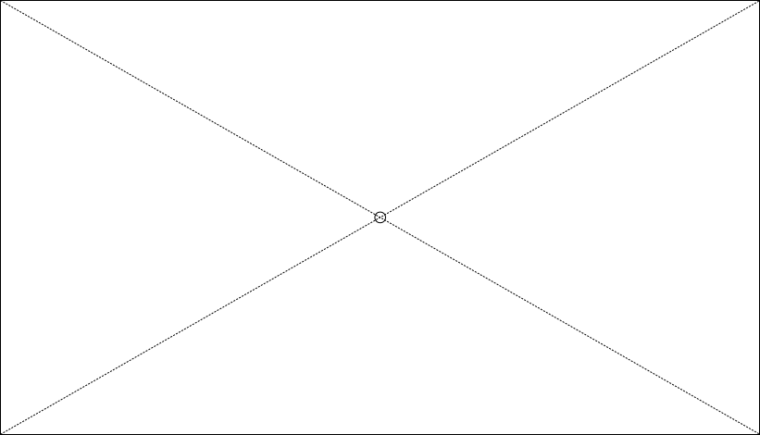

Figure 1: Template of a kamal board. The dimensions are 21 cm x 12 cm. The dashed lines indicate how to find the middle of the board at their intersection (Credit: M. Nielbock, own work).

For each kamal, prepare a thin piece of ply wood (approx. 4 mm) with 21 cm x 12 cm in size. If that is not available, a piece of very stiff cardboard of equal size is also possible. Determine the centre of the board by drawing or scratching two diagonal lines that connect opposite corners. Drill a hole through the centre that is big enough to permit the cord to fit through. It must also be small enough to not let it slide out again after tying a knot.

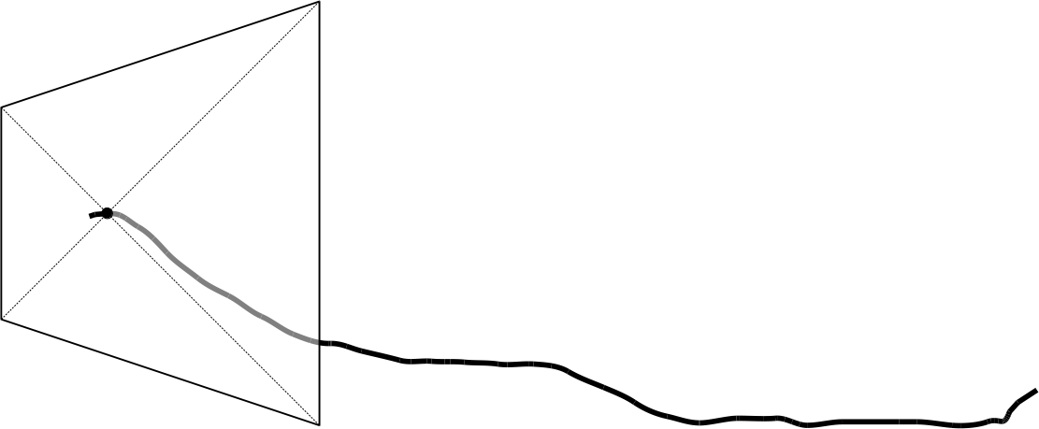

Figure 2: The kamal after running the cord in the central hole (Credit: M. Nielbock, own work)

Tie a knot at one end of the cord and run it in the central hole of the board. The knot should block the cord from sliding through the hole.

Now add knots at distances from the board as indicated in Table 1. Be careful to keep the cord straightened. Check the correct position of the knots with the ruler.

Table 1: Dimensions and relations between angles and lengths of a kamal.

|  |  |  |
| --- | --- | --- |
| **Angle subtended**  **(°)** | **Cord length with short side up**  **(cm)** | **Cord length with long side up**  **(cm)** |
| 30 | 41.6 | **25.1** |
| 35 | 36.0 | **22.2** |
| 40 | 31.9 | **20.0** |
| 45 | **28.8** | 18.3 |
| 50 | **26.3** | 17.0 |
| 55 | **24.2** | 16.0 |
| 60 | **22.5** | 15.2 |
| 65 | **21.1** | 14.4 |
| 70 | **19.9** | 13.8 |

Fill out the table on the worksheet by entering the number of knots and the corresponding angles. The first knot is the one next to the kamal board.

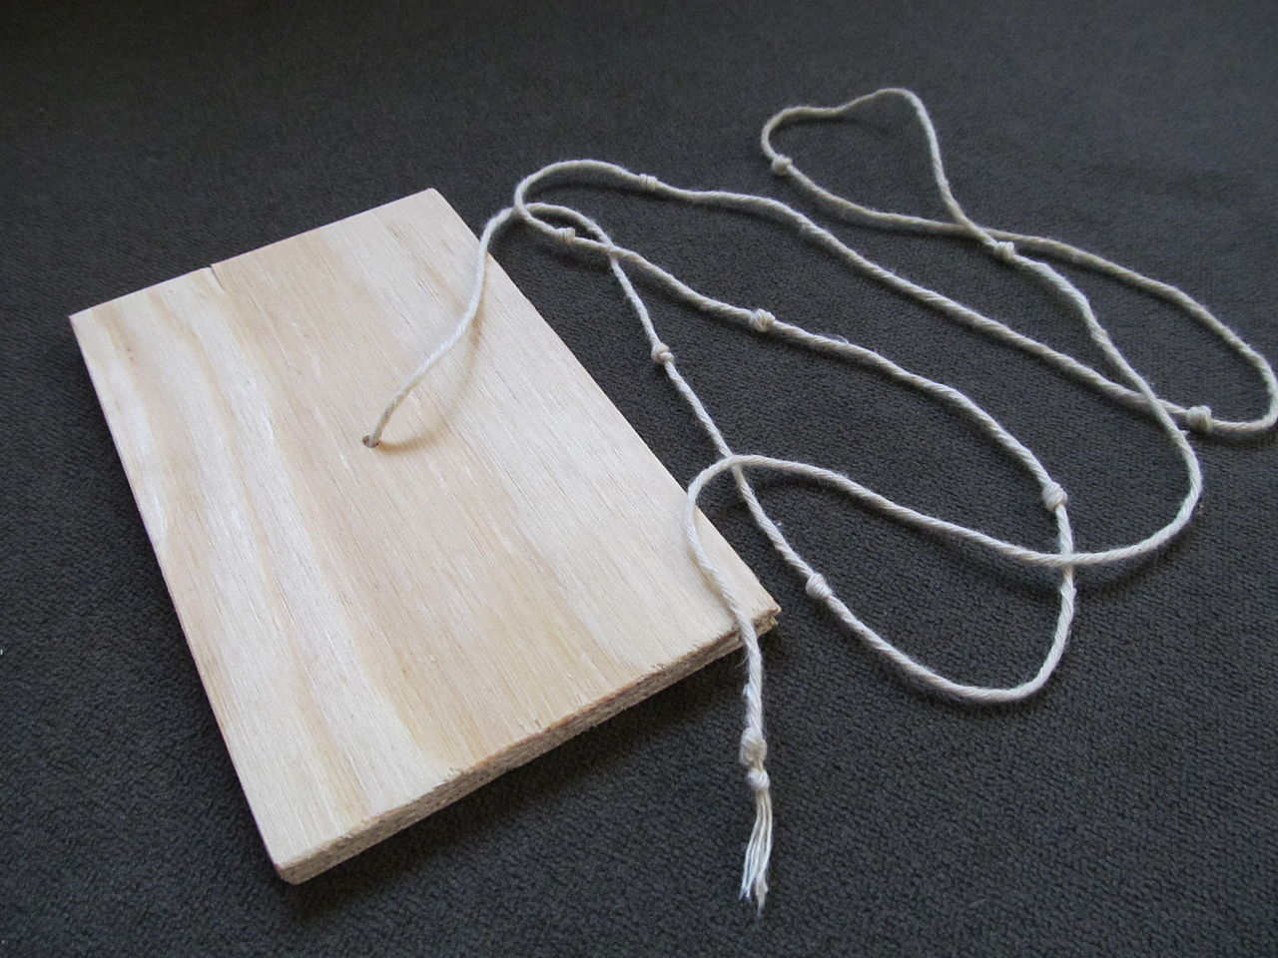

Figure 3: A simple wooden kamal. It consists of a surveying board and a cord with a line of knots (Credit: Bordwall <https://commons.wikimedia.org/wiki/File:Simple_Wooden_Kamal_(Navigation).jpg>, „Simple Wooden Kamal (Navigation)“, <https://creativecommons.org/licenses/by-sa/3.0/legalcode>).

**Worksheet: Angles in the sky**

The kamal is a navigational tool invented by Arabian sailors in the 9th century AD. Its purpose is to measure stellar elevations without the notion of angles. If you stretch out your arm, one finger subtends an angle. This method appears to have been the earliest technique to determine the elevation of stars. In the Arabian world, this “height” is called *isba* (إصبع) which simply means *finger*. The corresponding angle is 1.5°.

This method was standardised by using a wooden plate, originally sized roughly 5 cm x 2.5 cm, with a cord attached to its centre. When held at various distances, the kamal subtends different angles between the horizon and the stars. Knots located at different positions along the cord denote the elevations of stars and, consequently, the latitude of various ports.

When the Portuguese explorer Vasco da Gama set out to find the sea passage from Europe to India in 1497, he stopped at the Eastern African port of Malindi, where the local Muslim Sheikh provided him with a skilled navigator of the Indian Ocean to guide him to the shores of India. This navigator used a kamal for finding the sailing directions.

With this activity, you will work as a navigator using the kamal. The table below lists the angles that correspond to the knots tied during manufacturing the kamal.

Table 1: List of knots and angles of the kamal.

|  |  |
| --- | --- |
| **Knot #** | **Angle (°)** |
|  |  |
|  |  |
|  |  |
|  |  |
|  |  |
|  |  |
|  |  |
|  |  |
|  |  |

**How to use the kamal**

Here are a few rules to remind when using the kamal.

* Remember the orientation of the kamal. For large elevations, hold it with the short edges up and down.
* Hold the near end of the cord at your lips.
* Keep the cord straightened.
* Hold the kamal board perpendicular to the line of sight.

Measuring the elevation of Polaris, the North Star, is done following the steps below (see Figure 1).

1. Find Polaris.
2. Align the lower edge of the kamal board with the horizon.
3. Change the length of the cord until the upper edge touches Polaris.
4. Check both alignments.
5. Count the knots starting from the kamal board.

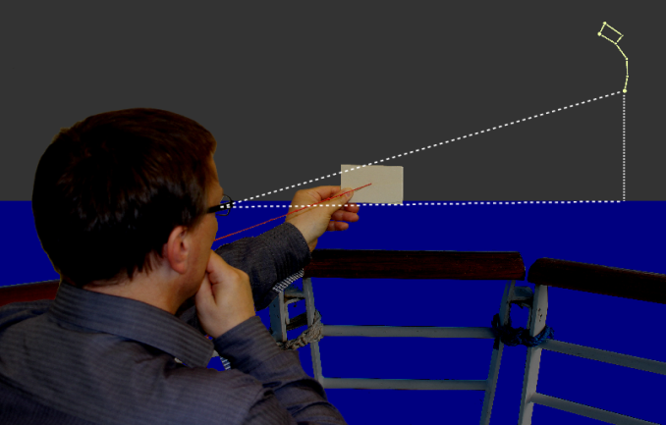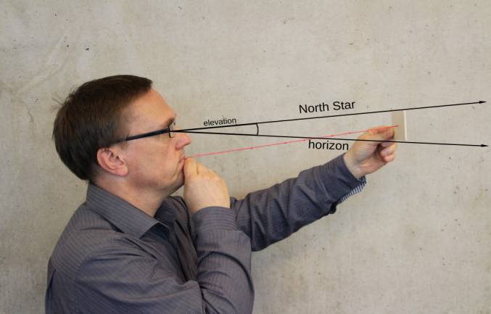

Figure 1: Illustration of how the kamal is used to measure the elevation of Polaris. See text for additional information (Credit: Markus Nielbock, left: <https://commons.wikimedia.org/wiki/File:Kamal_Polaris.png>, right: <https://commons.wikimedia.org/wiki/File:Kamal_Polaris_Side.png>, <https://creativecommons.org/licenses/by/4.0/legalcode>).

When comparing with the list of knots above, you find the angle you have measured. Estimate the angle between two knots, if the length of the cord is in between. Fill in the empty spaces in the following paragraph.

The length of the cord is at knot # _________________ .

This corresponds to an angle of ______________________ degrees.

You have determined the elevation of Polaris, i.e. the angle between the horizon and the star. This value is identical to the latitude of your position on Earth.

If you compare your result with the students, how much do the values differ? Can you imagine a reason for this?

How would that have affected real navigation?

**Analysis**

In order to see how accurate your measurement is, consult a map that contains coordinates or online services like Google Maps or Google Earth. Find your location on Earth and the coordinates of your position.

In Google Earth, you can right-click on your location and then click on “What’s here?”. A small window appears at the bottom of the screen that lists two numbers. The first is the latitude in degrees with decimals.

Latitude: __________________________

Perhaps, the values do not match as well as you had thought. Can you imagine why?