What is a constellation?
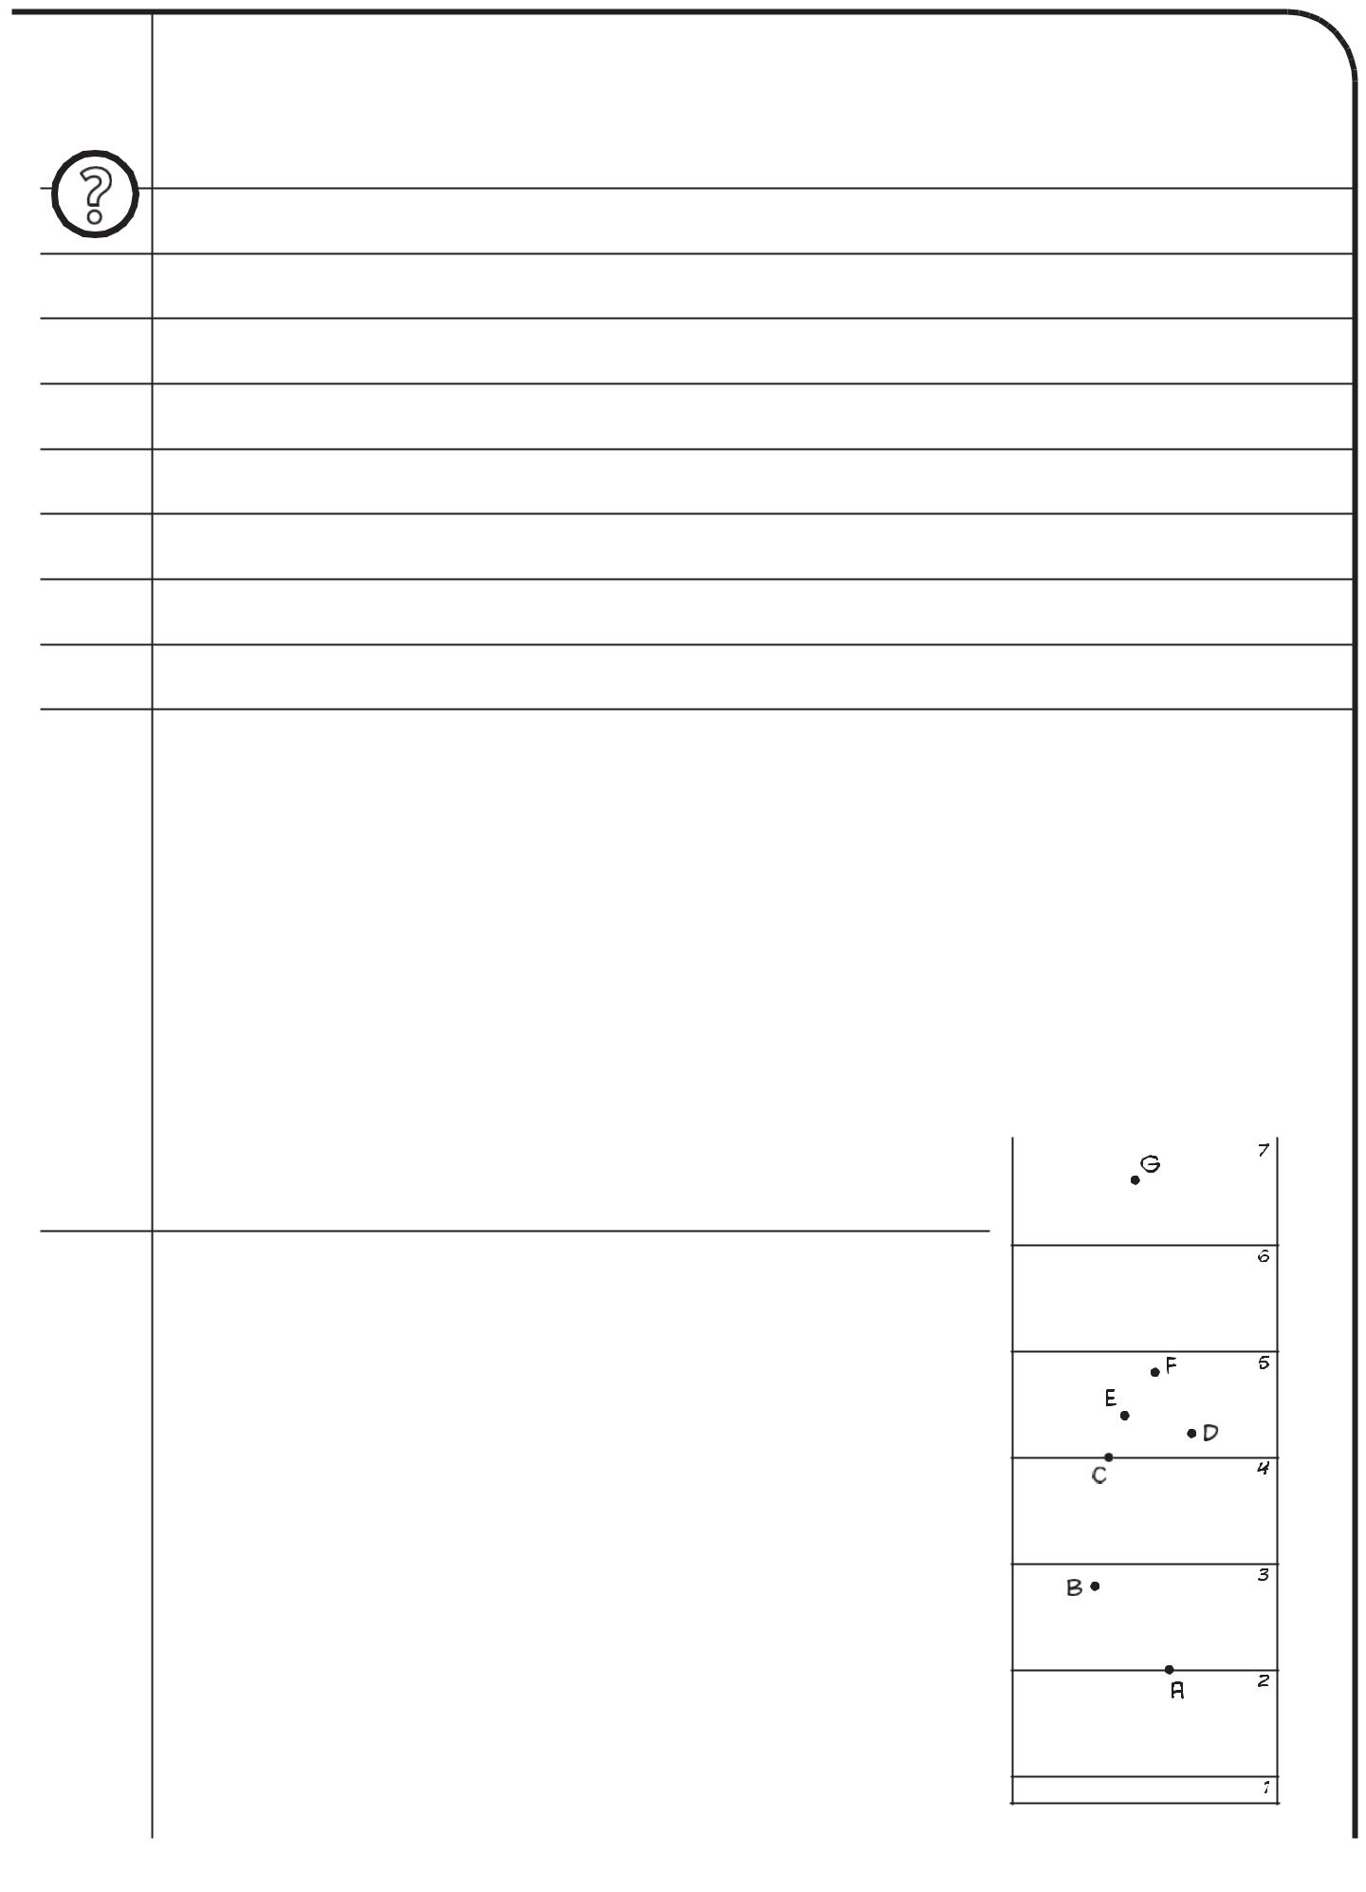

You are going to answer the following research question:

What does a constellation look like when seen from different sides?

- Make a constellation

- Collect a container with the material you need from your teacher.

- Examine the items in the container. Take out the long piece of cardboard.

- Draw a straight line two centimetres from the short edge of the cardboard. Write a 1 under this line as shown in figure 1.

- You now have to divide the rest of the cardboard into six equal parts as shown

 | in figure 1. Measure the length of the cardboard |  |  |  |  | from line 1.
 | The length of the cardboard is |  |  |  |  |  |  |  |  | centimetres.
5 | Divide this figure by six. Write your answer here:
 |  | : | 6 = |  |  |  |  |  |  | centimetres.
6 | Starting at line 1, measure the number of centimetres you calculated in
 | step 5. Draw a straight line here. Write a 2 under this line.
7 | Repeat step 6 until you have drawn six lines in total.
 | The seventh line is the top of the cardboard.

Line 1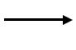

Figure 1
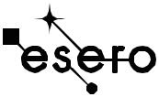

Looking at constellations

workshee
t

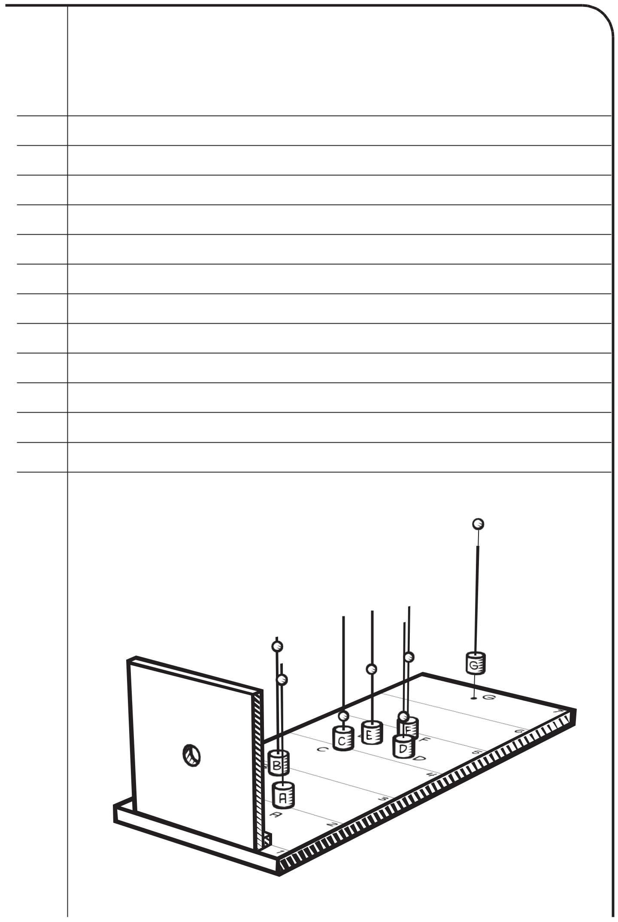

- Next you will make the eyehole. Take the square piece of cardboard (20*20 cm). Draw a cross exactly in the middle of the card. Use the compass to draw a circle with a diameter of 1 centimetre on this cross. Ask your teacher to cut out this circle for you before doing step 9. You can start step 10 while waiting for your teacher.

- Glue a thin piece of cardboard (2*20cm) to the long piece of cardboard along line 1. Use scotch tape to attach the square cardboard to this thin piece of cardboard as shown in the drawing below (figure 2).

- Now you are going to make a three-dimensional model of the constellation Orion on your board. The drawing below (figure 2) shows exactly where each star forming Orion should be. Each star has been given a letter from A to G. Stars A and C, are positioned exactly on a line (lines 2 and 4). Stars D, E, F are located in between lines 4 and 5. Use the pencil to mark the letters A to G on the board using figure 1 and 2 as a guide.

Figure 2

Looking at constellations
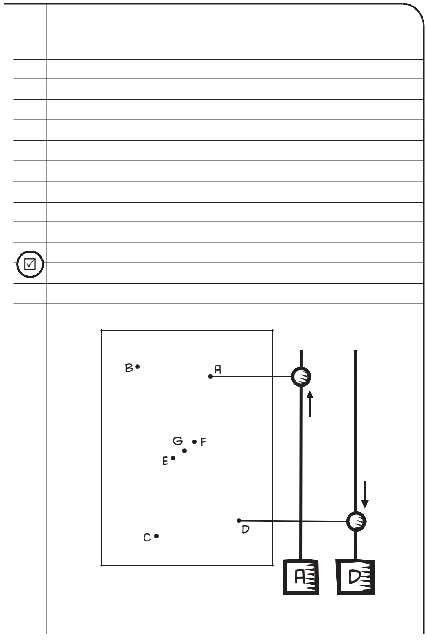

- Use the waterproof marker to label each piece of corks with a letter from A to G.

- Take the 7 wooden skewers and stick one in each of the lettered corks.

- Take the glow-in-the-dark modelling clay and roll seven small balls about the size of a pea. Slide one ball onto each skewer. Each ball represents a star.

- Place the corks over the corresponding letters on the board. Figure 3 shows how high each ball needs to be on the skewer. Ball A should be very near the top of the skewer. Ball B is also high. Balls C and D should be near the bottom of the skewer. Balls E, F, and G should be almost halfway down the skewer.

- Look through the eyehole in your cardboard square to see if the stars are in the correct place. The constellation should look the same as in the drawing.

Figure 3

Looking at constellations
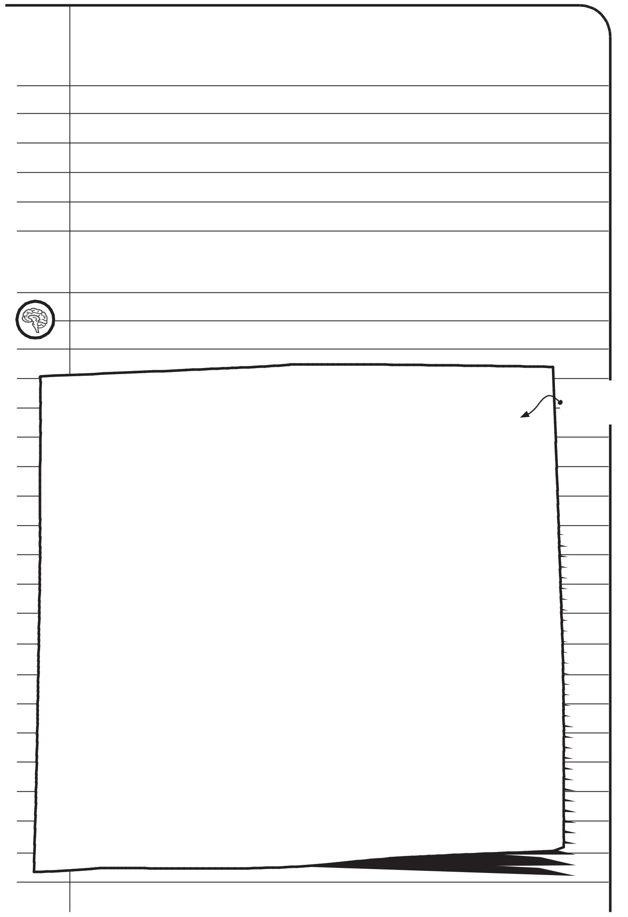

- Does your constellation look the same? If not, go through steps 10 to 14 again. Other reasons why your constellation doesn't look the same may be:

  - the balls representing the stars are too large

  - the balls are not at the correct height on the skewers

  - the hole you are looking through is too small, so you cannot see the whole constellation

- Not in the same plane

You have now made a three-dimensional model of the constellation Orion. Look

through the eyehole. In the box below, draw what your constellation looks like.

draw what
you see
HERE

Looking at constellations
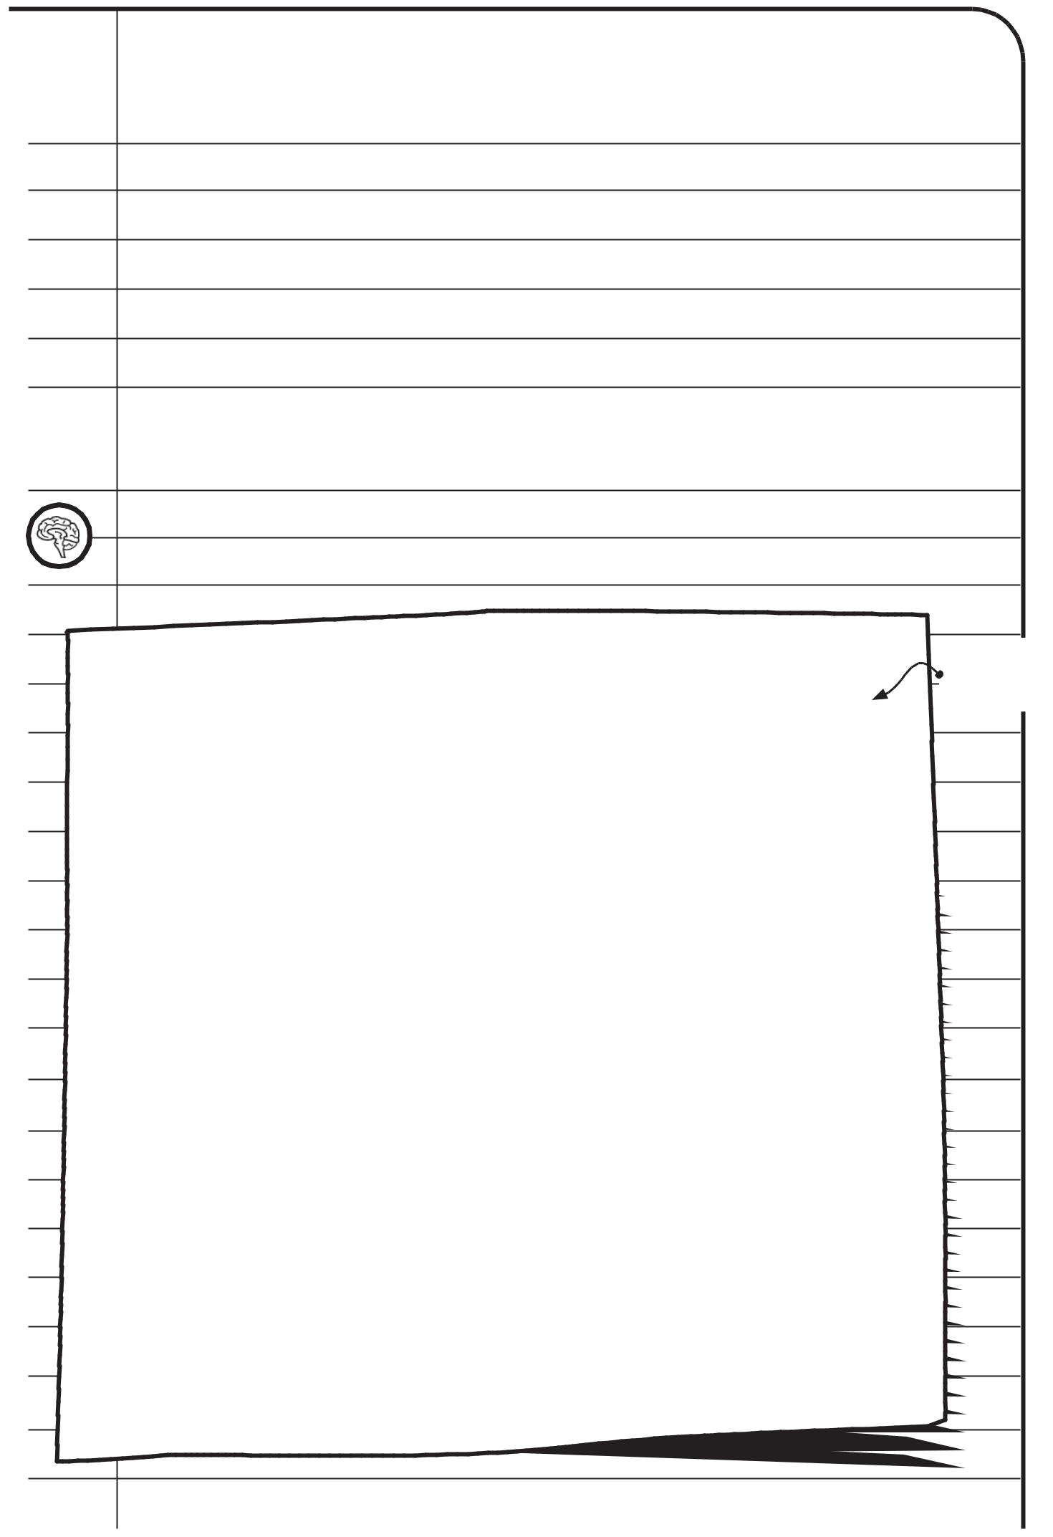

In the box below, draw what your constellation looks like from another side. Does

it look the same as your first drawing?

Looking at constellations
The Orion constellation
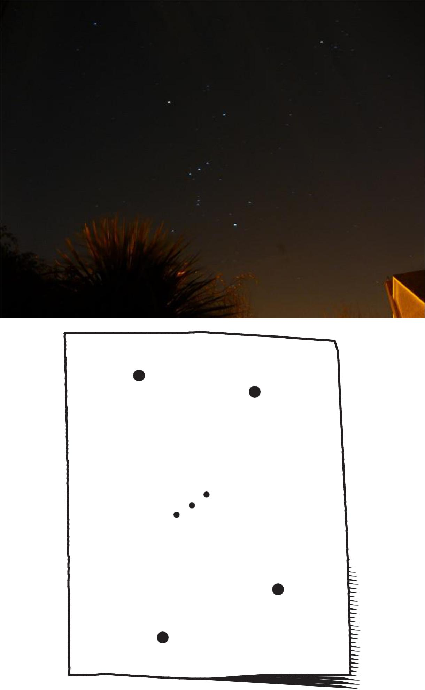

Looking at constellations

